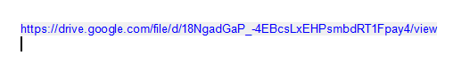
Hi, to download the Siemens NX 12 version, copy the following link and start the download. Then, watch the class to see how to install it.

